BIOL 2510 Learning Objectives 3AB
Lecture 3A
- Describe the first line of defense against cellular injury.
The first line of defense mainly contains physical and chemical barriers which are designed for protecting the body from any form kind of infection. These chemical and physical barriers contain friendly bacteria, neutrophils, skin, mucus, stomach acid, tears, cilia, and urine flow.
- Assign the formed elements of the blood to the correct bone marrow stem cell lineage (myeloid vs lymphoid).
Lymphoid stem cells they give birth to a class of leukocytes termed as lymphocytes, for example T cells, B cells, and natural killer cells, they all function in immunity purposely. but hemopoiesis of lymphocytes progresses somehow in a different way from the process for the other composed elements. In nutshell, lymphoid stem cells in a quick move they migrate from the bone marrow to lymphatic tissues, inclusion of the lymph nodes, spleen, and thymus, it is here their differentiation and production is achieved and continues. First B cells are so named since they mature in the bone marrow, as the T cells are matured in the thymus.
Myeloid stem cells give birth to all the other designed elements, with the inclusion the erythrocytes; megakaryocytes that produce platelets; and a myeloblast lineage that gives rise to monocytes and the other three forms of granular leukocytes: neutrophils, eosinophils, and basophils
- Describe the structural and functional features of the five major types of white blood cells (three types of granulocytes and the two types of agranulocytes).
White blood cells in the immune system their role is to fight the entry of infections as well as defending the body from foreign materials in cases of coming into contact. for the purpose of this function, white blood cells are formed of different parts that are designed to kill intruders by the generation of antibodies designed to protect the body due to future bacteria exposure not only for the bacteria but also for other attacks like viruses.

Types of white blood cells
  - Neutrophils; are designed to first and respond to bacteria and also any virus detected
  - Eosinophils; are designed specifically for the role of dealing with allergy symptoms
  - Basophils; are designed in the role of asthma detection symptoms
  - Lymphocytes; their role is to fight infections by antibody production corresponding to the infection
  - Monocytes; this part of white blood cells is to clean body by removal of dead cells.
- Describe the structural and functional features of primary lymphoid organs and secondary lymphoid organs and tissues.
Primary lymphatic organisms are responsible for the formation of mature lymphocytes. It is here the environment for cell division as they mature to T and B cells respectively is created.
These organs are mainly two;
  - Thymus gland
  - Redbone marrow
B and T also mature in the bone marrow, as later the T cells will migrate to the thymus for maturation.
Secondary organisms and tissues are arranged in a series of filters for the purpose of monitoring the content from the extracellular fluids for example blood, lymph, and tissue. The lymphoid tissues that are to filter each fluid are being arrayed differently. In the secondary tissues is where we have the activation of lymphocytes
- Give three examples of antigen-presenting cells (APCs) and describe how antigen-presenting cells (APCs) travel from body tissues to the secondary lymphoid organs and tissues.
During antigen presentation, for example from the dendritic cells, we have the lymphocytes migrating towards the germinal centers on the secondary lymphoid tissues. Here they undergo clonal expansion as well as affinity maturation. The secondary lymphoid tissue will provide a conducive environment for the antigens to interaction with the lymphocytes.
- Explain how an immature lymphocyte becomes a self-tolerant lymphocyte.
When an immature self-reactive lymphocyte being at a position to bind its antigen at the central lymphoid where there is cell production, it may be triggered to alter the receptor so that the tolerance to self-antigens might break down thus causing B and T cells to react against the own tissue antigens.
- List the ways inflammation (the second line of defense) acts to protect the body from infection and injury.
For the response to the tissue injury, the body initiates chemical signals to signal pathways involved in the regulation of inflammatory mediators are located in the resident tissue cells and also cells regulated from the blood stream. Inflammation is just common pathogenesis composed of many chronic diseases for example bowel disease, arthritis, cardiovascular and cancer. Ways inflammation responds.
  - Inflammatory cells are recruited.
  - Cell pattern receptors recognize detrimental stimuli
  - Inflammatory pathways are activated
  - Inflammatory markers are also released.
- Describe the initiation of the inflammatory response by ligand/TLR binding.
The signals from the TLR lead to multiple outcomes for instance induction of inflammatory or the regulation of genes, cellular proliferation, cell surface expression of the co-stimulatory molecules, and also antibody switching of class production. All of the above outcomes are just direct results of activation based on several transcription factors, for example, nuclear factor kappa light chain which will enhance the activation of activator protein B cells, and the interferon regulatory factors. all the TLRs activate AP-1 and NFkB as the activation of IRF7 and as well IRF3 will be regulated by different usage of the signal adapters and the cellular compartment at the origin of the signals. The main role of the different transcription factors is to drive mainly pro-inflammatory kind of responses.

- List the cardinal signs of inflammation and explain them in terms of the vascular effects of inflammatory chemicals.
Cardinal signs of inflammation are;
  - Heat this is due to an increase in blood flow towards the inflamed human body area.
  - Redness is also due to increased blood flow towards the inflamed human body area.
  - Pain is due to the release of chemicals for stimulation of the nerve endings as well as the loss of function due to a combination of factors.
  - Swelling, is also due to the accumulation of factors

- List the four biochemical pathways that may be activated in response to injury or infection.
  - The flow is also known as the catabolic phase
  - The ebb as well as the early shock phase based on the decreased metabolism.
  - The convalescent has also known as the anabolic phase when resynthesizing the lost tissue in the body
- Describe the three processes affected by the end-products of the arachidonic acid pathway.
Cyclooxygenase process- it is the chemical reactions and pathways for formation of prostaglandins from arachidonic acid, and in which prostaglandin-endoperoxide synthase (cyclooxygenase) catalyzes the committed step in the conversion of arachidonic acid to the prostaglandin-endoperoxides PGG2 and also PGH2.
Omega- hydroxylase - The chemical reactions in which the way that the arachidonic acid is converted into other various compounds, the first way is through the omega-hydroxylation.
Epoxygenase process- The chemical reactions as well as the way that the arachidonic acid is converted into other compounds, including the epoxyeicosatrienoic acids and dihydroxyeicosatrienoic acids.
- Describe the relationships between arachidonic acid pathway enzymes (phospholipase, COX1, COX2) and these anti-inflammatory medications: corticosteroids, aspirin, indomethacin, ibuprofen, and celecoxib.
(AA) metabolites appear to play an important role but as yet undetermined the role of the signal, which is dependent on the epithelial cell locations. AA and eicosanoids are the intermediate stages, that is, the signal is the methods for the growth factor. (AA) and eicosanoids are the effectors and targets of the other the messenger of interaction. The majority of the tumor cells to produce AA metabolites and to those of the compounds have been found to modulate a wide range of biological factors that induce tumor growth and invasiveness. Currently, the studies of the special contribution to the special the enzymes of AA metabolism are the main focus of the research. These enzymes are to inject the oxygen molecules in a variety of positions in order to produce AA of the various hydroxyl compounds known as eicosanoids. All of the enzymes involved in the metabolism of AA and it is quite closely related to the activity, the mechanisms of the, and substrate preferences.
- Discuss the roles of fibrin and bradykinin in the inflammatory response.
Bradykinin is involved in plasma nociception, extravasation, vasodilation, and bronchoconstriction. Bradykinin mediates the inflammation process by causing vasodilation, increasing the vascular permeability and also stimulate the synthesis of prostaglandins.
- Describe the two pathways (classical and alternative) of complement activation.
Classical pathway
This pathway involves compliment such as C4, C2, and C1. The pathway is triggered by antigen-antibody complexes that bind to C1. C1 has the 3 sub-components C1s, C1q, and C1r. the pathway will form a C3 convertase, C4b2a, which will later split C3 into two fragments. The large part which is C3b covalently attaches itself towards the surface of the microbial pathogens as it opposes them. On the other side the small fragment called C3a is set for activation of the mast cells, this, in turn, causes the release of the vasoactive mediators for instance histamine.
Alternative pathway
This pathway involves various factors, I, B, D, and H. these factors interact with each other like C3b to form the C3 convertase, C3bBb, to activate more C3, making the pathways to be also known as the amplification loop. This activation is therefore promoted based on the presence of fungal and bacterial cell walls which later is inhibited by the molecules for the service of the normal mammalian cells.

- Describe the functions of complement proteins (C3a, C3b, C5a, C5b) in the inflammatory response.
C3b binds to the pathogen surface, which later leads to greater internalization by phagocytic cells by opsonization. There is also the formation of C5 convertase by the classical pathway during the binding of C4b and also C2b. C5a being an important chemotactic protein as it helps recruit inflammatory cells.

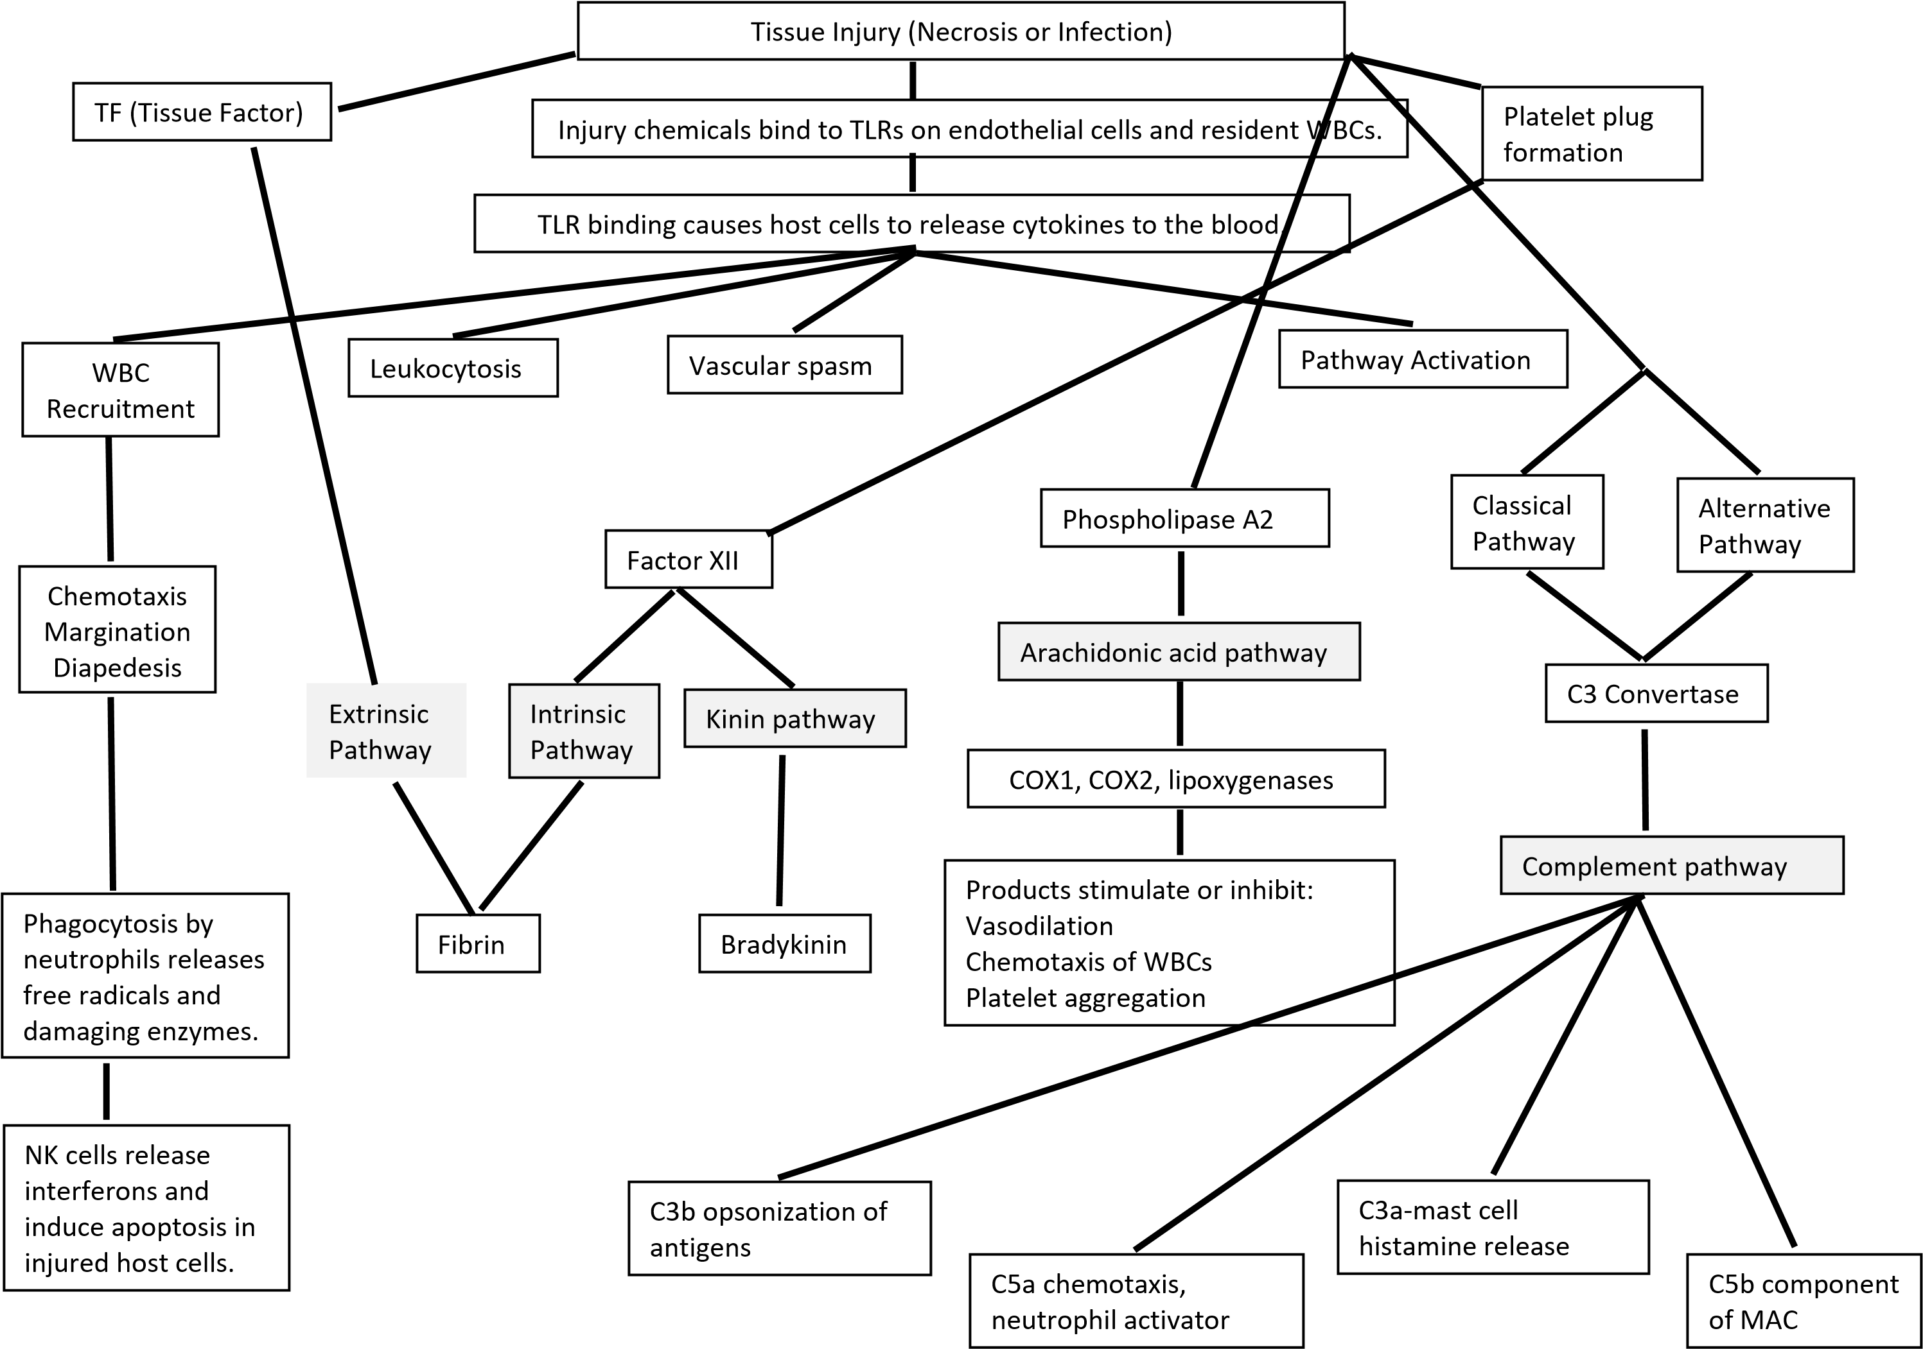
Lecture 3B
- Describe the steps in the recruitment of WBCs to the site of inflammation (leukocytosis, chemotaxis, margination, diapedesis).
Leukocyte migration simply involves the passage from the tissue to the lymphatic vessels to the blood and from vessels to the blood as well. Cells undergo multistep stages in a binding process to the endothelium vessel
Chemotaxis
It is the involvement of the cellular reactions of directional sensing and motility that makes the cells sense as well as move through the extra chemical gradients
- Discuss the source and function of interferons.
During the skin and mucosal infections, fibroblasts, epithelial cells, tissue-resident macrophages the DCs secrete IFN-I which restricts viral replication. For the infected organisms, IFN-I is being produced by fibroblasts, DCs, tissue-resident, as well as the parenchyma cells
- List the roles of macrophages in repairing the damage done to host tissue by inflammation.
Macrophages are set to play a critical role in the maintenance, resolution of inflammation, and initiation. Macrophages are activated and also deactivated in the inflammation process. The inhibition of the inflammation by deactivation or by the removal of mediators as well as the inflammatory effector cells permits the host to repair damaged tissues of the body.
- Describe the reason for chronic inflammation and resultant granuloma formation.
For autoinflammatory diseases, chronic inflammation is set to result due to the formation of the granulomas, these are simply the clusters for the immune cells at the affected tissues. The common cause of all the granuloma formation is tuberculosis that is worldwide.
- Describe the types and functions of exudates (serous, fibrinous, hemorrhagic, purulent).
Types of exudate
  - Serous- this is clear, watery, and thin plasma.
  - Seropurulent- it is a yellow, thin, watery, and cloudy
  - Serosanguineous- it is pale, thin and watery, and red to pink in color
  - Sanguineous- it is seen in full-thickness wounds and deep partial

Mainly the role of exudate is to facilitate the diffusion of various vital healing factors for example immune factors and also growth factors. They also facilitate the migration of cells across the wound bed. Exudate also provides cells with nutrients basically for cell metabolism, promotes cell proliferation as it also aids in autolysis of necrotic or damaged tissues.
- Discuss the clinical manifestation of systemic inflammation and list the cytokines that cause it.
Clinically, the systemic inflammation response syndrome is identified by 2 or more symptoms for instance, tachypnoea, fever/hypothermia as well as the change in blood leucocyte count. Cytokines that cause clinical inflammation include interleun-1 (IL-1), IL-12, IL-18, tumor necrosis factor-alpha, interferon-gamma stimulate factor for granulocyte-macrophage.
- Describe the clinical tests for systemic inflammation (sedimentation rate, C-reactive protein).
Serum protein electrophoresis (SPE)- This test is designed to measure specific proteins in the blood. This is to help in the identification of some diseases.
Plasma viscosity- it is designed to give an acute phase response for example the increase in the assorted plasma proteins as well as fibrinogen in blood plasma which is being stimulated by a given variety of causes for instance inflammatory disease, infection, and neoplasm. this test is also used in diagnosing a host disorder.
c-reactive protein (CRP)- this is a protein that is made by the liver. The CRP levels are set to increase in the blood subjected to a non-conditioning cause of inflammation at a certain place in the body.
Erythrocyte sedimentation rate (ESR)- this is a type of blood test that is used to measure how quickly the erythrocytes will settle at the bottom of a given test tube with a blood sample. In normal conditions, red blood cells settle gradually. In case we have faster compared to the normal rate; it indicates that there is inflammation in the body.

- Describe the two types of pyrogens (internal vs external) and their role in fever generation.
Internal/ endogeneous pyrogens
They enter into the perivascular space of the OVLT across the fenestrated capillary wall for stimulation of cells to produce prostaglandin E2(PGE2). Later diffuses into the adjacent preoptic area for upturning temperature set point thus causing fever.
External/exogenous pyrogens
They initiate fever simply by inducing the host cells also known as primary macrophages so that they can produce as well as releasing endogenous pyrogens, for example, interleukin-1 that had multiple biological functions that are essential for human immune response.
- Differentiate between cell-mediated immunity and humoral immunity
Humoral immunity | Cell-mediated immunity
Secrets antibodies for fighting antigens | Secrets cytokines while no antibody for fighting the antigens
Is quick in action towards antigens | Has a slow delay with a permanent impact against any pathogens.

- External concerning the type of lymphocytes involved.
- Differentiate between a naïve lymphocyte and an effector lymphocyte.
The naive lymphocyte is the essential component of the immune system that enables the body in fighting new and unrecognized infections as well as diseases. While the effector is simply enriched for the response to recall the antigen, they have a lower activation threshold compared to the naïve lymphocyte.

- Draw the process of activation of a naïve cytotoxic T cell against body cells that are infected or malignant. Show the surfaces of the two cells involved and label the following: MCH I, TCR, CD8, a fragment of the antigenic protein. Photograph your drawing and insert it here.

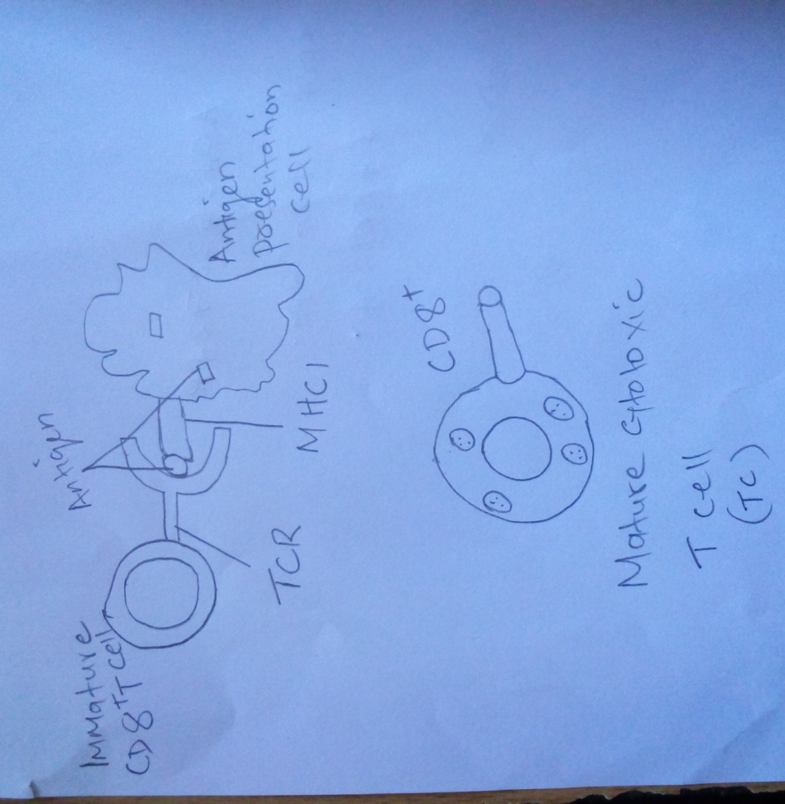
- Describe the functions of the effector cells and the memory cells that result from the clonal expansion of an activated cytotoxic T cell.
Effector cells become the essential components of the immune system that enables the body in fighting new and unrecognized infections as well as diseases. While the memory cells are simply enriched for the response to recall the antigen, they have a lower activation threshold compared to the naïve lymphocyte

- An activated cytotoxic T cell differentiates into effector cytotoxic T cells and memory cytotoxic T cells during clonal expansion. Explain what differentiation means at the molecular (DNA) level.
Cellular differentiation is the process through which a cell changes its gene expression to become a more specific type of a given cell. That single cell will carry the DNA coding for all the proteins the adult organism is going to use.
- Draw the process of activation of a naïve helper T cell against an antigen that is presented by a dendritic cell. Show the surfaces of the two cells involved and label the following: MCH II, TCR, CD4, IL-2, IL2 receptor, and a fragment of the antigenic protein. Photograph your drawing and insert it here.
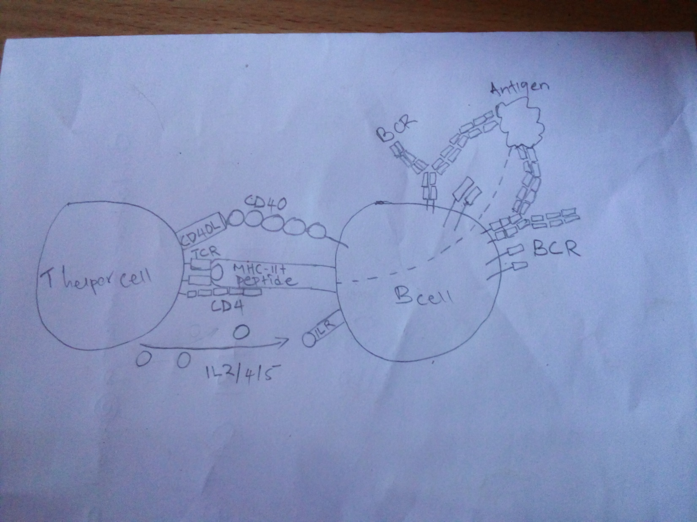

- Describe the functions of the effector cells and the memory cells that result from the clonal expansion of an activated helper T cell.
Effector cells-These are the relatively short-lived and activated cells that defend the body in any immune response. They secret antibodies to activate the T cells inclusion of cytotoxic T cells as well as the helper T- cells which enables to carry the cell-mediated response. On the other side, the memory T cells become a necessity for protective immunity against the invading pathogens more so under conditions of immunosuppression. It is also noted that their presence threatens the transplant's survival thus making the transplantation a great challenge.

- Differentiate between the activities of the two types of effector helper T cells: TH1 cells and TH2 cells.
Th2 and Th1 play a great role in immunity. Th2 stimulates humoral immune response as it promotes B cell proliferation as induces antibody production. On the other side, Th1 cells stimulate the cellular immune response which participates in the inhibition of macrophage activation as it stimulates B cells so that it produces IgM, IgG1.
- Differentiate between NK cell recognition of an injured (infected or malignant) host cell and cytotoxic T cell recognition of an injured host cell concerning specificity.
NK cells do recognize and kill cells that have downregulated MHC class I molecules from their cell surface. They express the low-affinity IgG receptor CD16. The will help them also to recognize and kill the target cells that are opsonized with the antibodies by the antibody-dependent cell that is mediated cytotoxicity. On the other side, the cytotoxic T cell primarily acts by the calcium-dependent release of the specialized lytic granules upon recognition of antigen on the surface of the target cell. It is also noted that granules which store and granzymes perforin are seen in armed CD8 of the cytotoxic effector cells based on the tissue lesions.
- Describe the two ways NK cells and cytotoxic T cells kill a target host cell (perforins/granzymes vs FasL).
The NK cells are activated for the response to the macrophage or interferons that are derived from cytokines. They serve to contain viral infections whereas the adaptive immune responses do generate the antigen-specific cytotoxic T cells that can clear the infection. The NK cells do work to control viral infections; this is by secreting TNFα and IFNy.
- Describe how the antigens involved in cytotoxic T cell activation differ from the antigens involved in helper T cell activation. (Where are the antigens synthesized in each case?)
T cells help other cells of the immune system while on the other side the cytotoxic T cells kill virally infected cells as well as tumors. But for the antibody, the TCR cannot be able to bind antigen directly.

SUMMARY:

Adaptive Immunity

-
Cell-Mediated Immunity
Humoral Immunity

Intracellular Antigen AAntigenAntigAntigenAntigen

Displayed with MHC I

On
Sick
Body Cells

To Naïve Cytotoxic T cells

Extracellular Antigen

Displayed with MHC II

On APCs (macrophage/dendritic cell)

To Naïve Helper T cells

Extracellular Antigen

Displayed with MHC II

On B cells

To Effector Helper T cells

Effector

Cytotoxic T cells

Memory
Cytotoxic T cells

Wait

Effector

Helper T cells

Memory

Helper T cells

Wait

Effector B cells

(
Plasma Cells)
Kill Sick Body Cells

Perforins/Granzymes

OR

FasL to FasR

Memory

B cells

Wait

Th1

:

*stimulate T cells, NK
cells, macrophages

*secrete IL2, INF gamma

*role in autoimmunity

Th2

*stimulate B cells

*secrete IL4, 5, 10, 13

*role in allergy

Antibodies Released

IgM

IgA

IgD

IgG

IgE

